

**AGENDA**

**1) Welcome** (Saluting Officer)

**2) Opening of the board** (Facilitator)

**3) Presentation of the attendees** (Registrar)

**4) Review and approve of the agenda** (Facilitator)

**5) Review and approval of the minutes of the last meeting** (Registrar)

**6) Business to be discussed** (Facilitator)

* Presentation on CAASPP with Dr. Loan Tran
* Presentation on Parent Engagement with Dr. Israel Gonzalez

**7) Events and announcements**

* Family Resource Center Food Distribution every 2nd and 4th Tuesday of the month from 2 to 4pm or until runs out
* Turkey Box giveaway at San Joaquin County Fairgrounds:1658 S. Airport Way, November 22nd 8am to 1pm

**8) Other business**

* Next Stockton Unified School District Migrant Parent Meeting: Thursday, December 15, 2022 at 6:00 PM at the Stockton Unified School District Office: 56 S. Lincoln Street
* Stockton’s Migrant Education Facebook page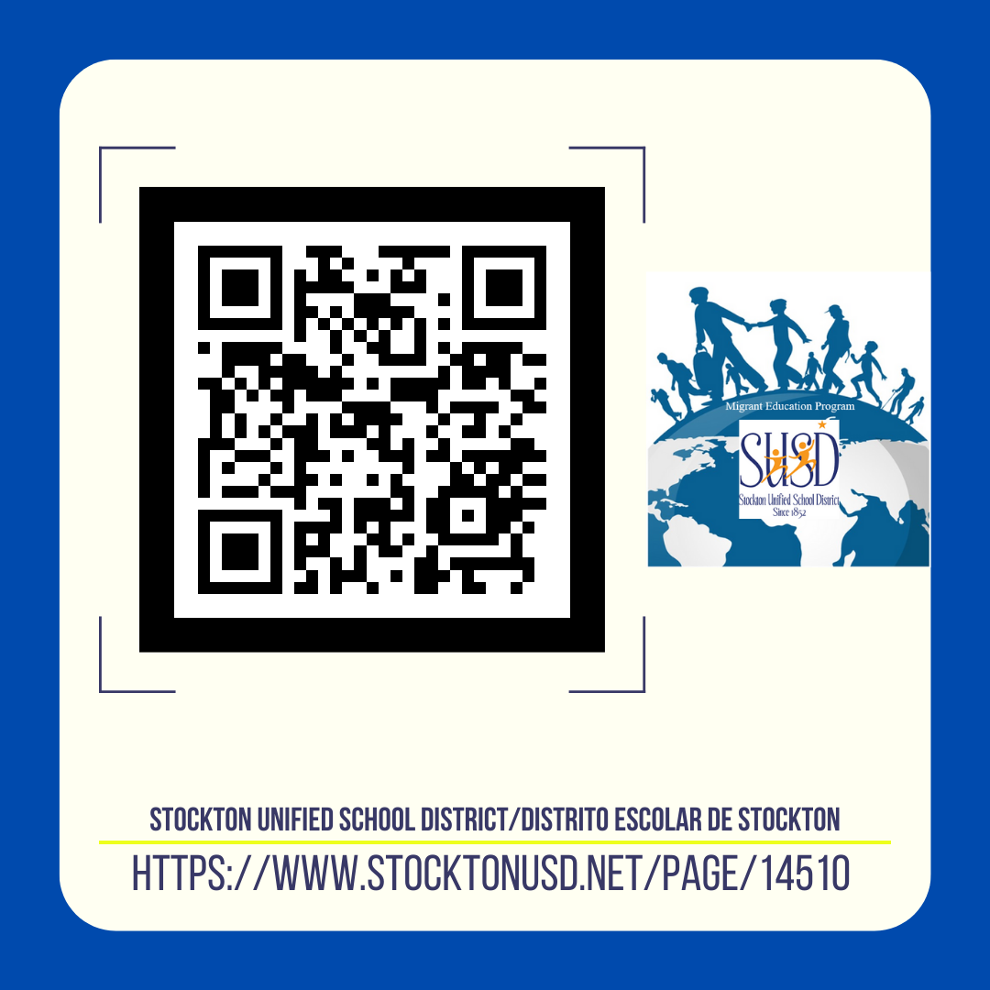

**9) Closure of the meeting**