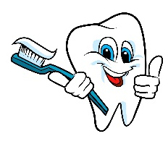**SERVICES**

• Flu Vaccinations

• Crisis Stabilization

• Dental Screening

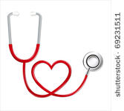• First Aid

• Health Education

• Individual and Family Counseling

• Supportive Counseling Services

• Referrals to Outside Services

• Sports Physicals

• Substance Use Prevention

• Support Groups for Anger Management, Substance Use, Personal Responsibility, Smoking Cessation, Mentoring, and Life Skills

• Trauma Counseling

• Mentor Services

The Chavez Wellness Center serves the medical and mental health needs of students Chavez High School.

Students under the age of 18 must have parental consent, however,

***All services are confidential***.

**THE STAFF**

Rosie M. Fernandez

Wellness Center Coordinator

209/933.7480 ext 8931

Maryann Soria, RN

(209) 986-6244

Neetu Kapoor, LVN

Margaret (Maggie) Torres, Health Care Assistant

209/933.7480 x 8777

Tiffany Craver – MH Clinician

209/933.7480 x8810

***Delta Health Care***

• Sports Physicals & Smoking Cessation /Substance Abuse Counseling and Student Mentoring

***CSU Stanislaus***

• Interns – Counseling Support

***PLUS Program***

* Student Mentors

**CCH School Counselors**

* Group Counseling

***• Parents By Choice***

Group and some individual counseling

***Stockton Unified School District***

• Mental Health Clinician

•Case Management

Serving the Titans Students …



**Health & Wellness Center**

Chavez High School

2929 Windflower Lane, A102/103

Stockton, CA 95212

209/933.7480 ext.8931

209/475.9097 fax

Monday – Friday*

7:00am – 3:00pm

\**When school is in session*

**Who are we?** The Chavez Health & Wellness Center is a health and wellness facility open to students attending Chavez High School. By having a health center on campus, students are able to receive services in a safe, youth-centered environment.

We encourage students to continue receiving services from their primary care physicians. However, the Chavez Health & Wellness Center is here to serve the immediate needs of the students.

Thank you to SUSD for supporting the Chavez Health & Wellness Center.



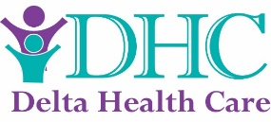 

The Health & Wellness Center at Chavez High School offers physical and behavioral health services on campus that help lead to healthier lifestyles.

**ACCESSIBLE**

• Services are free and available on campus.

**CONVENIENCE**

• No need to arrange for transportation or adjust parent’s work schedule.

• No need to miss class for long periods of time.

**RESOURCEFUL**

• Referrals can be made to outside agencies for additional services.

**MEDICAL SPECIALISTS**

• The Chavez Health & Wellness Center is staffed with trained medical professionals to provide quality services.

• All staff are trained to work with teens.

**BEHAVIORAL HEALTH SPECIALISTS**

• The Chavez Health & Wellness Center works with community agencies like Channel Medical Centers, Delta Health Care, and Parents By Choice to provide services and groups on campus.

• Current services include anger management, Mentoring, coping skills, anxiety, depression, personal responsibility, smoking cessation, substance use disorders, and suicide prevention.

**How do I receive services?**

It’s as easy as 1…2…3…

Step 1: Have your parent/guardian complete the consent form.

Step 2: Return the signed consent form to the Chavez Health & Wellness Center. The consent is valid for the duration of the student’s attendance.

Step 3: Request an appointment. Staff will schedule an appointment and make appropriate referrals.

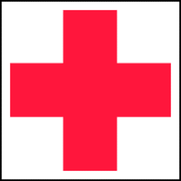

The staff at the Chavez Health & Wellness Center will teach you the importance of good physical and behavioral health. Staff offers education, prevention, and treatment that can lead to healthier lifestyles.

If you would like to schedule an appointment for a health assessment, please call 209/933.7480.

Research has shown, and teachers and educators intuitively know, that healthier children are better students because they are able to focus in class and are not distracted by hunger, pain, stress, or a chronic illness.

*-www.schoolhealthcenters.org*

*Let the Chavez Health & Wellness Center get you started on the path towards positive health and success.*